How to activate Data Analysis Toolpak in Excel

Activating the Data Analysis Toolpak in Excel is a quick process, but the steps differ slightly depending on whether you are using Windows or a Mac.
If it is already activated, the Data Analysis tool will appear under the Data tab in the top ribbon.
For Windows Users
- Open Excel and click on the File tab in the top-left corner.
- Select Options at the very bottom of the left-hand sidebar.
- In the Excel Options window, click on Add-ins from the left menu.
- At the bottom of the window, look for the Manage dropdown box. Ensure Excel Add-ins is selected, then click Go...
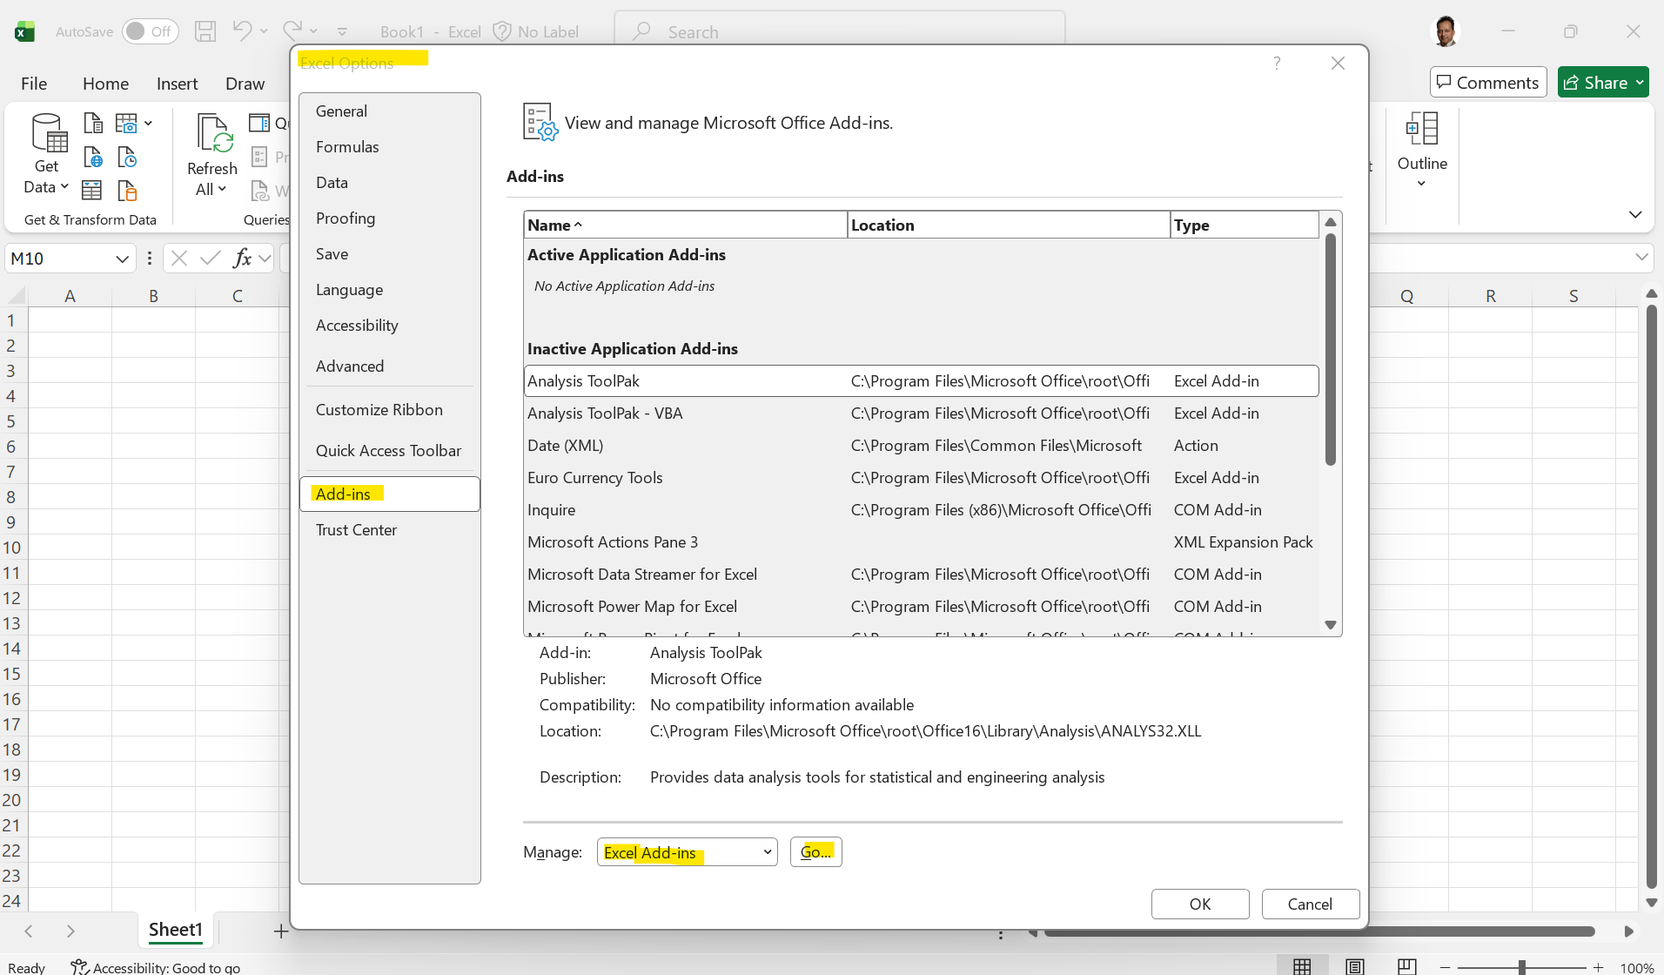
- A small "Add-ins" dialog box will appear. Check the box for Analysis ToolPak.
- Click OK.
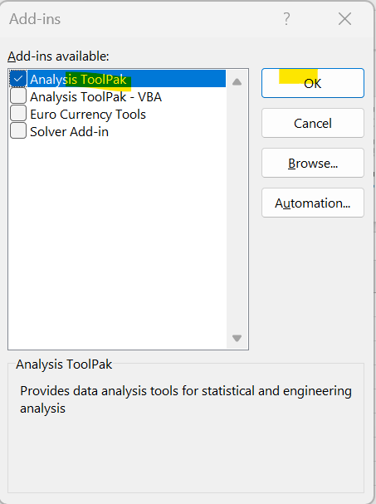
- Go to the Data tab in your ribbon; you should now see Data Analysis in the Analysis group on the far right.
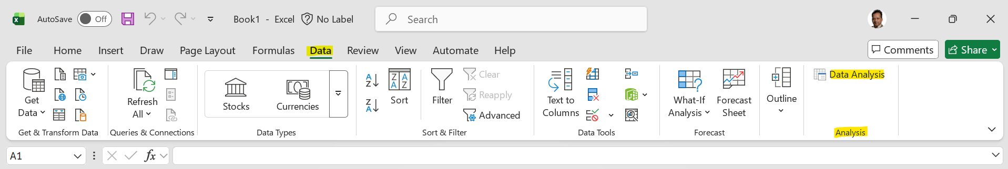

For Mac Users
- Open Excel and look at the top Apple menu bar (not the ribbon inside Excel).
- Click on Tools and then select Excel Add-ins...
- In the "Add-ins available" box, check the box for Analysis ToolPak.
- Click OK.
- To find the tool, click the Data tab in the Excel ribbon. Look for the Data Analysis button (it may be represented by a small gear icon or text depending on your window size).

Important Notes
- Excel for the Web: The Data Analysis Toolpak is not available in the browser-based version of Excel. You must use the desktop application.
- Missing from Ribbon: If you’ve followed the steps and don't see the "Data Analysis" button, try restarting Excel.
- iPad/iPhone: The Toolpak is not supported on mobile versions of Excel.

